SIMATS ENGINEERING
ASSESSMENT TOOL 1

COURSE CODE: MLA03
COURSE NAME: Reinforcement learning for Environment and Agent

COURSE OUTCOME COVERED

CO2: Apply Dynamic Programming methods to solve reinforcement learning problems and derive optimal policies for decision-making tasks. (BL2, BL3)

Assessment Tool Weightage: 35%

Dr DUMPALA PRASANTH

QUESTIONS: 10 Total Marks: 50

Annexure A

Industry Problem Task Duration: 2.5hrs

1. Explain how Reinforcement Learning can be applied to optimize delivery routes in a logistics system. Identify the possible states, actions, rewards, and policy. Discuss how continuous learning improves efficiency over time. (5 Marks)

2. Apply Reinforcement Learning concepts to a fraud detection system in fintech. Define the state space, action space, and reward mechanism. Explain how exploration strategies improve detection accuracy. (5 Marks)

3. Illustrate how Reinforcement Learning is used in a streaming platform for content recommendation. Discuss the impact of delayed rewards, user feedback, and changing preferences on learning performance. (5 Marks)

4. Evaluate the effectiveness of Reinforcement Learning in predictive maintenance compared to traditional rule-based approaches. Discuss risks and reliability concerns in industrial environments. (5 Marks)

5. Analyze how Reinforcement Learning can be used to optimize transportation systems such as bus scheduling or route allocation. Define states, actions, and rewards, and discuss how real-time data improves performance. (5 Marks)

6. Apply Reinforcement Learning to dynamic pricing in e-commerce. Define the state space, action space, and reward function. Discuss challenges in balancing exploration and exploitation. (5 Marks)

7. Illustrate the use of Reinforcement Learning in smart city waste management systems. Identify the MDP components and discuss how continuous updates improve operational efficiency. (5 Marks)

8. Evaluate how Reinforcement Learning can be used in network bandwidth allocation in telecommunications. Define states, actions, and rewards, and examine how the system adapts to dynamic conditions. (5 Marks)

9. Analyze the application of Reinforcement Learning in portfolio management in finance. Discuss advantages over traditional models and challenges such as risk and delayed rewards. (5 Marks)

10. Justify the use of Reinforcement Learning in renewable energy management systems. Define the RL framework components and discuss the impact of environmental uncertainty on decision-making. (5 Marks)

Code of Conduct:

I V. Nagendra (192425091) (Name / Reg No) certify that this submission is my original work and that I have adhered to the guidelines specified for this assessment.
I understand that any violation of academic integrity rules will result in disciplinary action.

V. Nagendra
Signature of the student:

RUBRICS FOR CALCULATION

Criteria | Weightage | Level 4 – Exemplary | Level 3 – Proficient | Level 2 – Developing | Level 1 – Beginning
Criteria | Weightage | Level 4 – Exemplary | Level 3 – Proficient | Level 2 – Developing | Level 1 – Beginning
Understanding of Industry Problem | 20% | Comprehensive understanding of real-world problem and constraints | Good understanding with minor gaps in requirements | Basic understanding; some requirements unclear | Poor understanding; misinterprets problem context
Application of Engineering Concepts | 25% | Applies advanced and relevant concepts effectively to solve the problem | Applies appropriate concepts with minor errors | Limited application of concepts | Incorrect or no application of concepts
Solution Design | 25% | Innovative, practical, and feasible solution aligned with industry standards | Logical and feasible solution with minor gaps | Basic solution with limited feasibility | Unclear or impractical solution
Use of Tools | 15% | Effective use of modern tools, technologies, and real data | Appropriate use of tools with correct implementation | Limited or inconsistent use of tools | Minimal or incorrect use of tools
Analysis | 10% | Thorough analysis with validated results and performance evaluation | Good analysis with reasonable validation | Basic analysis with limited validation | Poor or no analysis
Professionalism | 5% | Highly professional, well-documented, and clearly presented work | Good documentation and presentation | Basic documentation with some gaps | Poor documentation and presentation

1. Delivery Route Optimization
Question: Explain how RL can optimize delivery routes, including states, actions, rewards, policy, and continuous learning.

Answer
Reinforcement Learning (RL) can model a delivery network as a Markov Decision Process (MDP). The state can contain the vehicle's current location, remaining delivery stops, traffic level, vehicle capacity, time, and weather. Actions are choices such as selecting the next road or delivery stop, waiting, or changing the route. A positive reward can be given for on-time deliveries and completed stops, while penalties can represent travel time, fuel consumption, late delivery, congestion, and missed deliveries.
The policy maps each observed state to the best action. With continuous learning, the agent uses new traffic, delivery, and route outcomes to update its policy. Over time, it can learn recurring congestion patterns and prefer routes that reduce total travel time and operating cost. In a practical system, exploration should be constrained so that experimentation does not create unacceptable delivery failures.

Related Screenshot / RL Conceptual View
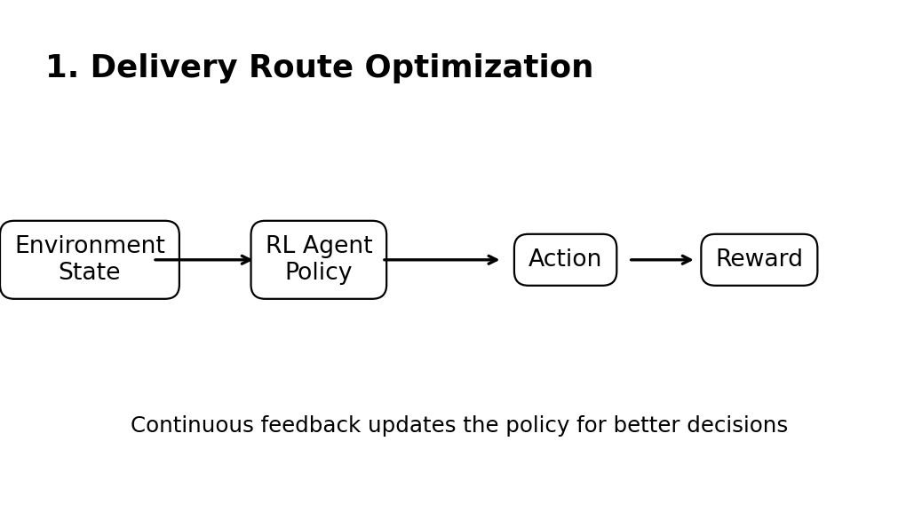
Figure 1: Conceptual RL interaction relevant to Question 1.

2. Fraud Detection in Fintech
Question: Apply RL to fintech fraud detection using state space, action space, rewards, and exploration.

Answer
RL can be applied by treating each transaction or short transaction sequence as an interaction with an environment. The state space may include transaction amount, location, time, merchant category, account history, recent transaction frequency, and a risk score. Actions can include approving a transaction, declining it, or sending it for additional verification.
The reward mechanism should reflect business outcomes: a correctly detected fraudulent transaction receives a positive reward, while allowing fraud produces a large penalty. Legitimate transactions incorrectly blocked should also incur a penalty because they reduce customer experience. Exploration strategies such as controlled epsilon-greedy or uncertainty-based exploration allow the system to discover new fraud patterns. Exploration must be limited in production because unsafe actions can directly affect customers and financial loss.

Related Screenshot / RL Conceptual View
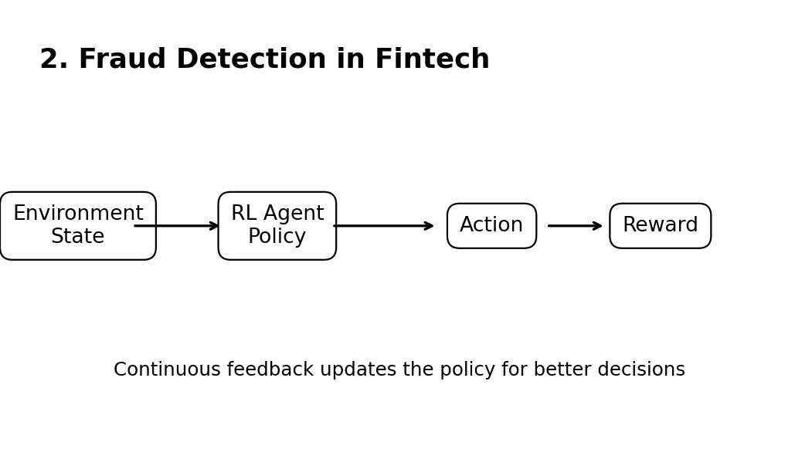
Figure 2: Conceptual RL interaction relevant to Question 2.

3. Streaming Content Recommendation
Question: Illustrate RL for streaming recommendations, including delayed rewards, feedback, and changing preferences.

Answer
A streaming platform can use RL to select movies, series, or other content based on a user's current context. The state can include viewing history, recent searches, watch duration, genre preferences, device, time of day, and recent feedback. Actions are the content recommendations or ranking decisions. Rewards can include viewing completion, continued watching, positive feedback, or return visits.
Delayed rewards are important because a recommendation may influence a user's later session rather than producing an immediate signal. User feedback such as likes, skips, ratings, and watch time provides learning signals. Preferences also change, so the agent must continue updating its policy rather than relying only on historical data. A balance between exploration and exploitation helps discover new interests while still recommending content that is likely to be useful.

Related Screenshot / RL Conceptual View
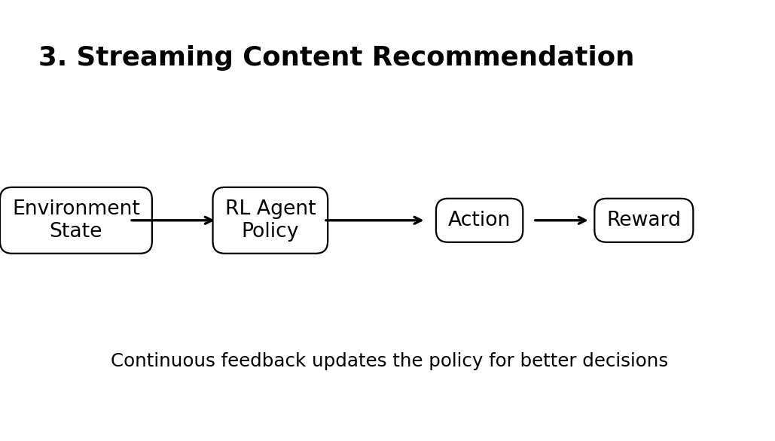
Figure 3: Conceptual RL interaction relevant to Question 3.

4. Predictive Maintenance
Question: Evaluate RL for predictive maintenance versus rule-based approaches, including risks and reliability.

Answer
RL can support predictive maintenance by learning when maintenance actions should be scheduled instead of relying only on fixed rules. The state can contain sensor readings, temperature, vibration, operating hours, load, previous maintenance history, and estimated equipment health. Actions may include continuing operation, inspection, preventive maintenance, or component replacement. Rewards can favour high availability and production while penalizing breakdowns, maintenance cost, downtime, and unnecessary replacement.
Compared with rule-based systems, RL can adapt decisions to changing operating conditions and optimize a sequence of maintenance decisions. However, industrial reliability is critical. Poor exploration can cause equipment damage, unsafe operation, or costly downtime. Therefore, RL should be trained in simulation or historical environments and deployed with safety constraints, monitoring, fallback rules, and human oversight.

Related Screenshot / RL Conceptual View
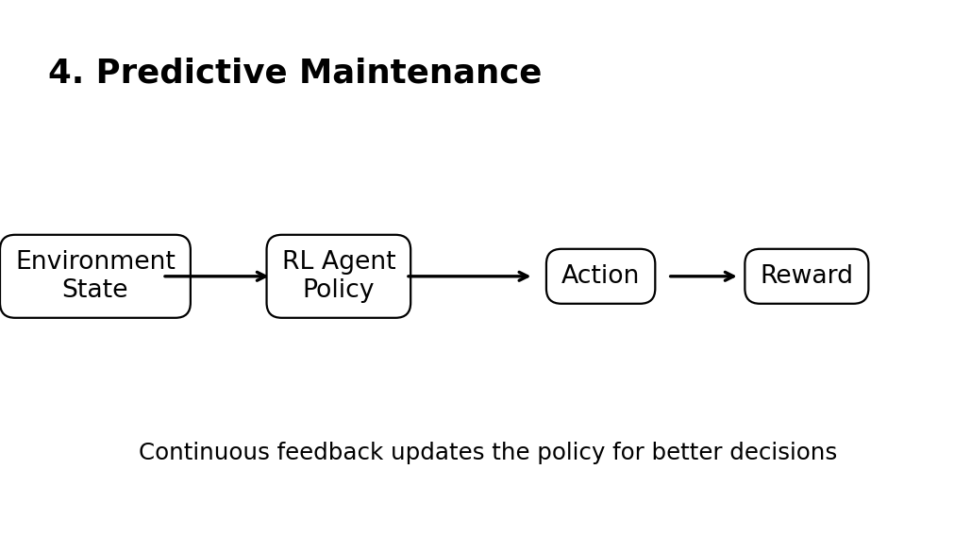
Figure 4: Conceptual RL interaction relevant to Question 4.

5. Transportation Scheduling
Question: Analyze RL for bus scheduling or route allocation using states, actions, rewards, and real-time data.

Answer
RL can optimize bus scheduling or route allocation by responding to changing passenger demand and traffic. The state can include bus locations, passenger waiting counts, traffic conditions, current timetable, vehicle availability, and time of day. Actions can include dispatching a bus, changing its route, adjusting frequency, or holding a vehicle briefly. Rewards can encourage lower passenger waiting time, good vehicle utilization, schedule reliability, and reduced operating cost.
Real-time data from GPS, passenger counters, traffic services, and ticketing systems makes the state more accurate. The agent can then react to congestion, unexpected demand, or delays instead of following a fixed schedule. A constrained policy is important so that optimization does not violate safety, capacity, service, or regulatory requirements.

Related Screenshot / RL Conceptual View
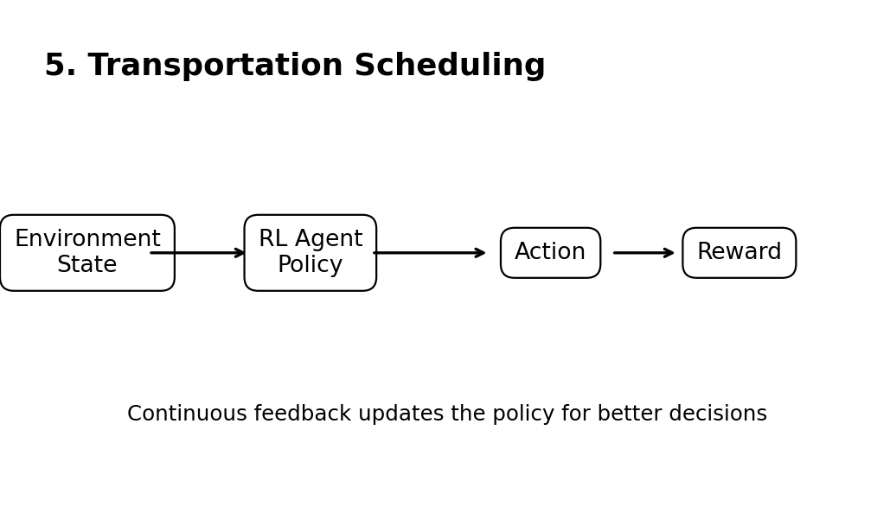
Figure 5: Conceptual RL interaction relevant to Question 5.

6. Dynamic Pricing in E-commerce
Question: Apply RL to e-commerce dynamic pricing using state, actions, rewards, and exploration/exploitation.

Answer
In dynamic pricing, RL can learn how to choose prices under changing demand. The state may include current price, historical sales, inventory, demand level, competitor price, season, time, and customer or market context. Actions are possible price changes or selected price levels. The reward can combine revenue and profit while penalizing stockouts, excessive discounting, or undesirable customer effects.
The main challenge is exploration versus exploitation. Exploitation chooses prices already known to perform well, while exploration tests other prices to learn demand response. Excessive exploration can reduce revenue or create unstable prices, whereas too little exploration can miss better pricing opportunities. Practical systems should use bounded price changes, business constraints, and offline evaluation before allowing online experimentation.

Related Screenshot / RL Conceptual View
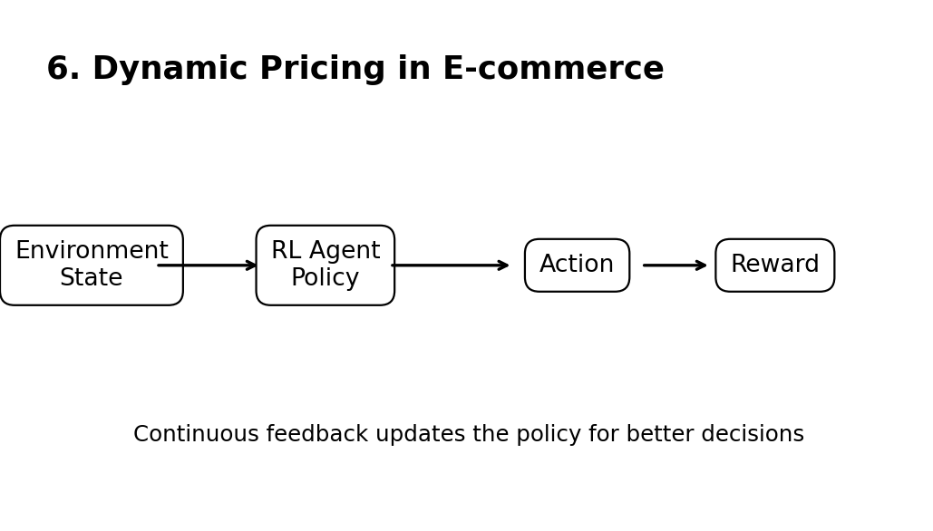
Figure 6: Conceptual RL interaction relevant to Question 6.

7. Smart City Waste Management
Question: Illustrate RL for smart-city waste management using MDP components and continuous updates.

Answer
RL can improve waste collection by deciding when and where collection vehicles should operate. The MDP state can include bin fill levels, vehicle locations, available vehicle capacity, traffic, weather, time, and historical waste-generation patterns. Actions can include selecting the next bin, changing a collection route, dispatching a vehicle, or delaying collection. Rewards can encourage high collection efficiency and low travel distance while penalizing overflowing bins, fuel use, missed service, and unnecessary trips.
Continuous updates from smart-bin sensors and vehicle GPS allow the policy to respond to current conditions. The system can learn which locations fill quickly and adjust routes accordingly. This can reduce unnecessary travel and improve service reliability. Operational constraints such as vehicle capacity, collection deadlines, and restricted roads should remain part of the decision process.

Related Screenshot / RL Conceptual View
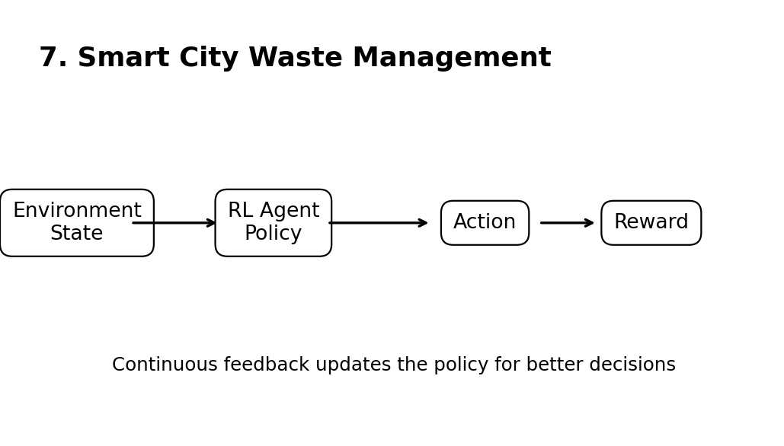
Figure 7: Conceptual RL interaction relevant to Question 7.

8. Network Bandwidth Allocation
Question: Evaluate RL for telecom bandwidth allocation using states, actions, rewards, and dynamic adaptation.

Answer
RL can allocate telecommunications bandwidth dynamically as network demand changes. The state can include traffic load, available bandwidth, queue length, latency, packet loss, service type, and user or application priority. Actions can allocate different bandwidth levels or scheduling resources among services. Rewards can favour high throughput, low latency, low packet loss, and efficient resource utilization while penalizing congestion and quality-of-service violations.
Because network conditions change rapidly, the agent repeatedly observes the environment and updates its allocation decisions. Real-time monitoring makes the state current, allowing the policy to react to traffic spikes or changing application requirements. Safety and service constraints should limit the policy so that high-priority services continue to meet their quality-of-service requirements.

Related Screenshot / RL Conceptual View
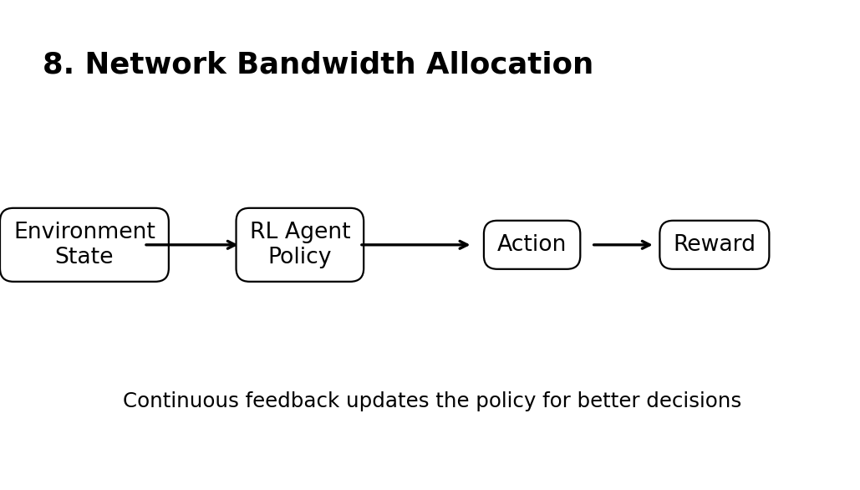
Figure 8: Conceptual RL interaction relevant to Question 8.

9. Portfolio Management
Question: Analyze RL for portfolio management, advantages, risk, and delayed rewards.

Answer
RL can treat portfolio management as sequential decision-making. The state can include asset prices, returns, volatility, portfolio weights, available cash, transaction costs, and market indicators. Actions can be buy, sell, hold, or adjust portfolio weights. The reward can be based on portfolio return after transaction costs, with penalties for excessive risk, drawdown, or undesirable volatility.
An advantage over a static traditional model is that RL can learn a sequence of decisions and adapt to changing market conditions. It can optimize long-term objectives rather than only a single prediction. However, financial rewards are noisy and often delayed, and market conditions can change. There is also risk of overfitting historical data. Risk limits, transaction-cost modelling, stress testing, out-of-sample validation, and conservative deployment are therefore necessary.

Related Screenshot / RL Conceptual View
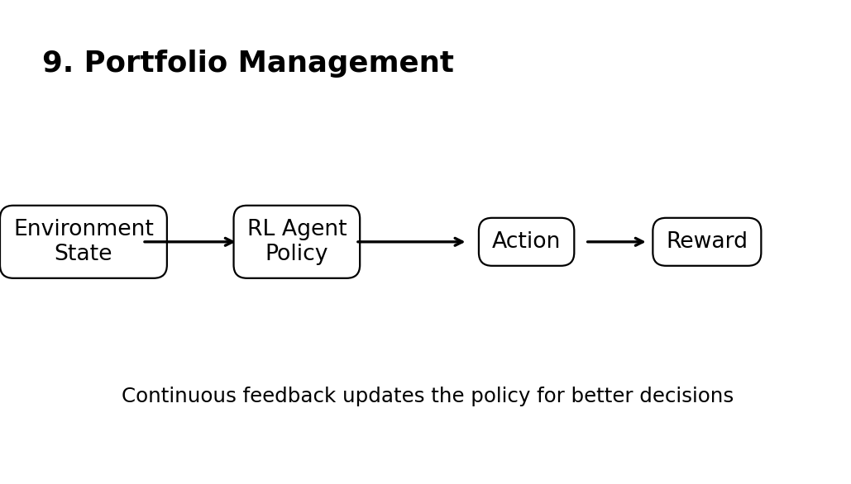
Figure 9: Conceptual RL interaction relevant to Question 9.

10. Renewable Energy Management
Question: Justify RL for renewable energy management, framework components, and environmental uncertainty.

Answer
RL is useful in renewable energy management because generation and demand vary with uncertain environmental conditions. The state can include solar or wind generation, weather forecasts, battery state of charge, electricity demand, market price, and grid conditions. Actions can include charging or discharging storage, scheduling flexible loads, buying or selling electricity, and allocating renewable generation. Rewards can encourage reliable supply, renewable utilization, and lower operating cost while penalizing shortages, excessive battery degradation, and grid violations.
Environmental uncertainty comes from changes in sunlight, wind, weather, demand, and market conditions. The agent must therefore make decisions with incomplete and changing information. Continuous observations allow it to adapt its policy. Safety constraints, battery limits, reserve requirements, and grid operating rules should be enforced so that the learned policy remains feasible and reliable.

Related Screenshot / RL Conceptual View
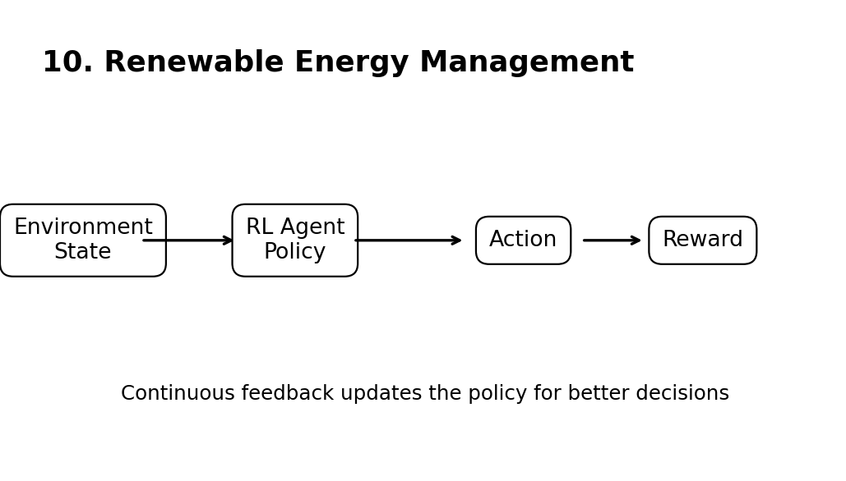
Figure 10: Conceptual RL interaction relevant to Question 10.

Conclusion
Reinforcement Learning provides a common decision-making framework for the ten industry problems. In each case, the problem can be represented using states, actions, rewards, and a policy, while continuous feedback enables adaptation. For real-world deployment, exploration should be controlled and domain constraints, safety, reliability, and validation should be included.

